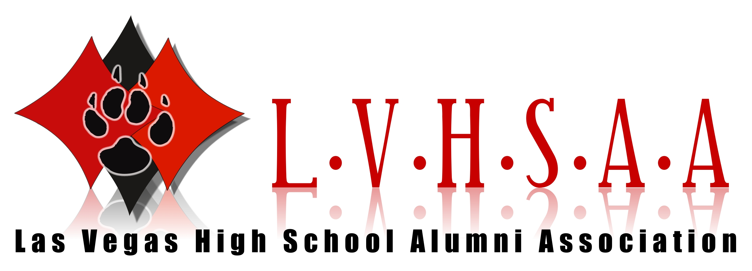

STELLA MASON PARSON (Class of 1948)

Stella was the first black woman to ever graduate from college in Nevada.

She graduated from UN Reno in 1952 with a bachelor’s degree in English. In 1988, she earned a master’s degree in marriage and family counseling at UNLV. She taught school for 33 years in Clark County. There is a Las Vegas elementary school named after her and her late husband, Rev. Claude H. Parson, Jr.

Stella was able to enroll at UNR in 1948, partly because of a scholarship she received from the Las Vegas chapter of the American Association of University Women.

In 2002, UNR awarded her a President’s Medal for her accomplishments and created a scholarship in her name. It is the Stella Mason Parson Endowed Scholarship established to encourage other female students of African-American descent to pursue a college education.

Stella passed away on July 29, 2016 in Las Vegas.

These biographies are based on research and could contain discrepancies.
If there are, any excerpts you feel should be changed please feel free to contact dave@lvhsaa.com

WWW.LVHSAA.COM

