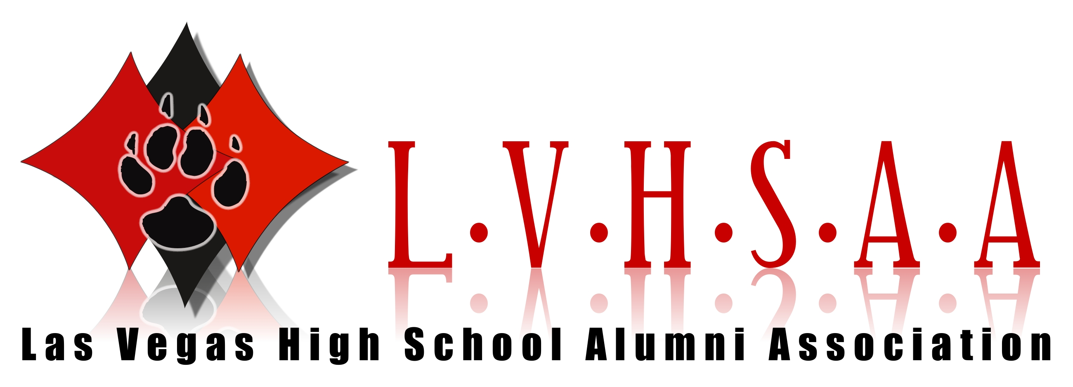
NORMAN TY HILBRECHT (Class OF 1952)

Norman was born in San Diego, CA. His family moved to Nevada when he was a young boy. After graduation, he continued his education at Northwestern University and graduated Cum Laude in 1956 with a Bachelor of Arts degree. He then attended Yale University and graduated in 1959. He served his country as a Judge Advocate General (JAG) Captain in the U.S. Army. Admitted to the Nevada Bar in 1959 he was a practicing attorney in Nevada for more than 50 years. His lifetime career included Nevada State Assemblyman 1966-1973 (Minority Leader 1971-1972) and Nevada State Senator 1974-1978. Norman founded and partnered at the Hilbrecht and Jones law firm 1962-1969. The firm expanded to Hilbrecht, Jones, Schreck and Bernhard 1969-1983. Norman served as President of the firm. In 1983, along with his wife Mercedes he founded the Norman Ty Hilbrecht and Associates law firm. Additional positions held by Norman in serving the State of Nevada and Clark County: included membership of the Clark County Democratic Central Committee, President of the Clark County Legal Aid Association, the Nevada Legal Air Defender Association. He was Vice President of the Nevada Trial Lawyers State Bar of Nevada Chairman for Administrative Law, President of Nevada Arbitration Association, and member of the State of Nevada Legislative Committee for the American Association of Retired Persons, Western Regional Assembly as Ombudsman and Nevada Supreme Court Settlement Judge. He served as counsel for many companies including Union Pacific Railroad, Local 1285 International Association of Firefighters, American United Health Care, New England Life, Northwest Transport, Sands Trucking, Searchlight Nugget & Skyline Construction to name a few. Additionally, he was a lecturer at the UNLV William S. Boyd School of Law.

Norman married Mercedes Sharratt in 1980. Together in 1983, they founded Norman Ty Hilbrecht & Associates, which emphasized Administrative law, Business & Agency Practice, Estate Planning Protection and Appellate Advocacy. His firm received accolades in many law publications. Norman and Mercedes were co-founders of the Las Vegas branch of the Mercedes Benz Club of America.

Norman was a lifetime member of the LVHS Alumni Association. He passed away on November 19, 2019 after a long battle with Parkinson’s disease.

These biographies are based on research and could contain discrepancies.
If there are any excerpts you feel should be changed please feel free to contact

WWW.LVHSAA.COM

