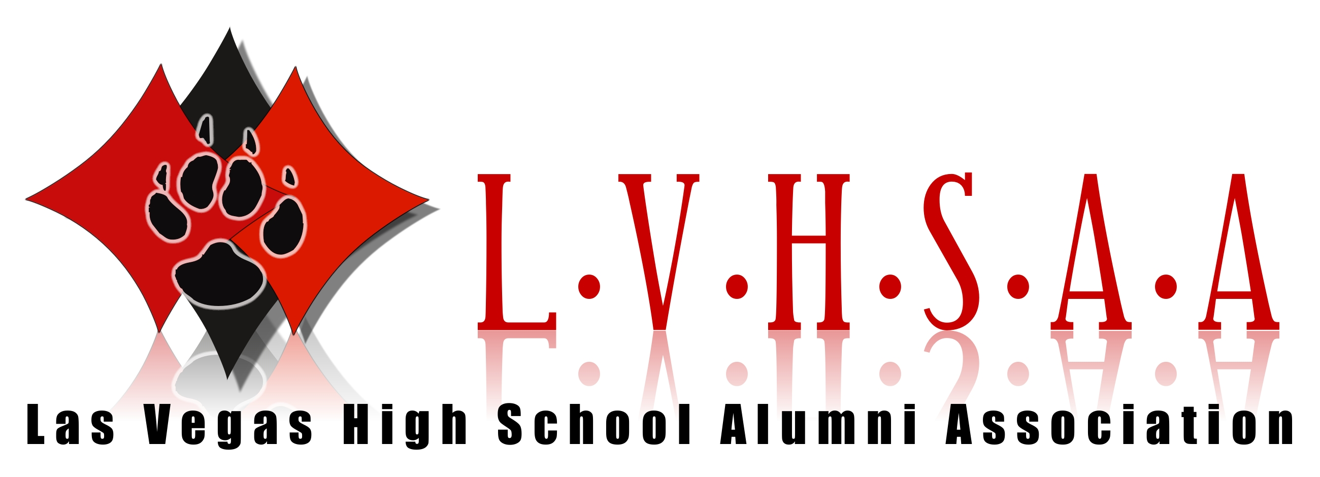
ROLLIE GIBBS (Class of 1954)

Rollie is a true Las Vegas native. He was born on a ranch in Las Vegas - where Sunset Park is located today. He attended Fifth Street Grammar School and graduated from LVHS in 1954. He entered his first Helldorado rodeo as a bull rider when he was an LVHS senior. The next year he started steer wrestling and won his first event! He entered the rodeo circuit in 1955 and traveled for 36 years. Rollie was an Advisor for rodeo clubs in Las Vegas high schools for numerous years and served as President of the Pro Rodeo Cowboys Association Wilderness Circuit for three years. He was Chairman of the Las Vegas Helldorado Rodeo for a year. He is a holder of an Emeritus Service Award for Club Scout Leaders. He was owner/operator of Rollie Gibb’s Crane Service in Las Vegas for over 25 years and previously worked for Butler Cranes for 35 years.

Rollie is a founding member of the LVHS Alumni Association. We are extremely fortunate to have had him as our President since inception in 2008. He has also been chairman of the Wildcat Reunion Committee since 2006. Along with Bruce Langson (1965), Rollie did the majority of the work in building our Wildcat float. All the work was done at Rollie’s crane yard, where the float is stored. In addition to building the float, Rollie also provided the trailer and a lot of the supplies, including the wrought-iron railings. It could not have been done without the use of all the equipment Rollie has at his yard - a forklift, a skip-loader, and a very large crane. How else could we have turned a 8 foot tall wildcat upside down to work on? In addition, what would we do without Rollie’s truck to pull the float in the parades!

Rollie spearheaded the Senior Squares Monument project. It was Rollie that came up with the design for the monument, and through his efforts we were fortunate to have time and materials donated by the architect, electrician, builder and landscaper, plus Rollie was responsible for getting the sealer and paint donated by Sherwin-Williams. During construction, Rollie was on-site almost daily, and along with several other alumni volunteers, painted the entire structure, saving us even more money!

Rollie is married to Naomi Lytle Gibbs (class of 1954). Rollie and Naomi reacquainted themselves at the Wildcat Reunion a few years ago and discovered they were both single. They married in 2013.

These biographies are based on research and could contain discrepancies.
If there are any excerpts you feel should be changed please feel free to contact dave@lvhsaa.com

