
JIM DYER (Class OF 1974)

Summertime baseball: runs, hits, errors … and memories

Post 8 of Las Vegas was the 1974 Nevada American Legion champion. Left to right: bottom row: Terry Holden (Class of 1973), John Rivera (Class of 1974), Ed Rogich (Class of 1975)
Middle row: Jeff Taylor (Class of 1975), Tim Lewis (Class of 1974), Steve Davies (Class of 1974), Bobby Sullivan (Class of 1974), Paul Fenstermaker (Class of 1976)
Top row: Kurt Garehime (Class of 1974), coach Joe Carpinelli, Glenn Page, Nick Trujillo, assistant coach Ben Dyer, Jimmy Dyer (Class of 1974).
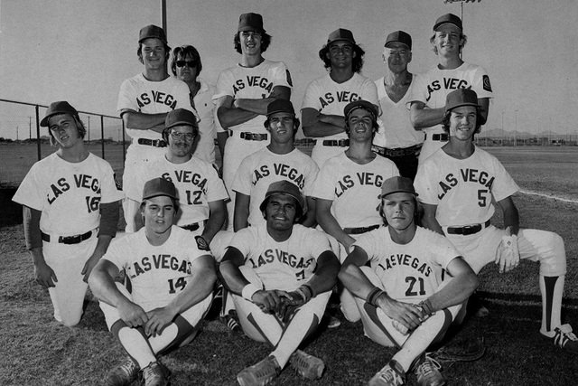

By RON KANTOWSKI LAS VEGAS REVIEW-JOURNAL
August 14, 2014
Kurt Garehime was on the first Las Vegas Little League all-star team, in 1968. That team, like all the others from Nevada before the Mountain Ridge kids, didn’t make it to Williamsport; it lost to the team from Reno that had Glenn Carano. This was before he was Glenn Carano, Dallas Cowboys (and Pittsburgh Maulers) quarterback. Then, he was just Glenn Carano, a 12-year-old pitcher “with a hellacious curve” according to Kurt Garehime. Six years later, Garehime played center field for the Post 8 American Legion team. He was the Most Valuable Player of the league. Post 8 didn’t make it to Roseburg, Ore., site of that year’s Legion World Series. It had just 12 players — 10 from Las Vegas High, a couple from Bishop Gorman. But it beat Post 51, mostly Rancho kids, for the summer baseball state title in 1974. Post 8 had Garehime, Glenn Page, Terry Holden, Tim Lewis, Steve Davies, Nick Trujillo. Most of those guys played college baseball. It had Ed Rogich, whose father, Ted, was a local American Legion pioneer; whose brother, Sig (Class of 1962), helped get a couple of presidents (Ronald Reagan, George H.W. Bush) elected as a political consultant.
However, Post 8 also was a star-crossed team. It had a kid named Jimmy Dyer at shortstop. Dyer was spiked in the first inning of the first game of the regionals up in Yountville, in California’s wine country. That was a big reason Post 8 did not make it to Roseburg, Ore., 40 years ago. In 1975, the White Sox selected Jimmy Dyer in the first round of the regular phase of the Major League Baseball Draft out of Arizona Western College in Yuma. In June, the Mets in the second round of the second phase picked him. He would sign with the Mets.
“Baseball has come a long way in Southern Nevada,” Ed Rogich said. “Marty Barrett stands out as probably the best ever (during the 1970s) but Jim Dyer could have been as good as Marty in the bigs, had he lived.”
Jimmy Dyer contracted a rare form of cancer and died when he was only 22. “Jimmy was a natural,” said Rogich, who played first base on those teams and went on to become a gaming executive.
“He and Marty stood out as two that just did stuff naturally that most of us would never achieve. Marty pulled off hidden ball tricks; Jimmy made plays that were impossible. They were both magical infielders. They say Jimmy was destined to be the next Mets shortstop … “He was buried in his (Jackson) Mets uniform”.
Kurt Garehime was Jimmy Dyer’s best friend on Post 8. ‘Defensively, Jimmy was very, very special,” said Garehime, who was teammates with Barrett and former big-leaguers Mickey Hatcher and Hubie Brooks at Mesa (Ariz.) Community College and now owns a successful beauty supply business. “I’ll tell you how good he was: His senior year, he hit .100 (Dyer’s father, Ben, wanted Jimmy to be a switch-hitter, so he batted mostly left-handed) and he was still voted all-state at shortstop. “He had remarkable talent. He played only one year of football, his senior year, and I believe he was second team all-conference; he was a starting guard on the state championship basketball team. He was a marvelous piano player. He had beautiful hands.” Jimmy Dyer could field a baseball like Luis Aparicio, he could play Duke Ellington on the piano, and he could play boogie-woogie, too. One just does not come across very often that combination. “But of all those skill sets, he was probably a better person”, Garehime said. “That’s probably the most painful thing for all of us when we look back at Jim. He was such a special guy, such a good-hearted person, such a warm individual. “Was he as good as Marty? No. Marty was the smartest player on the field. But Jimmy was extremely special.”

These biographies are based on research and could contain discrepancies.
If there are any excerpts you feel should be changed please feel free to contact dave@lvhsaa.com

WWW.LVHSAA.COM

