Chronology of Las Vegas High School
Written by Patty Haack, LVHS Class of 1956

Dates or
School Year Location Grades

1855-1857 Old Las Vegas Fort All grades

1904-1905 Tent - Las Vegas Creek All grades
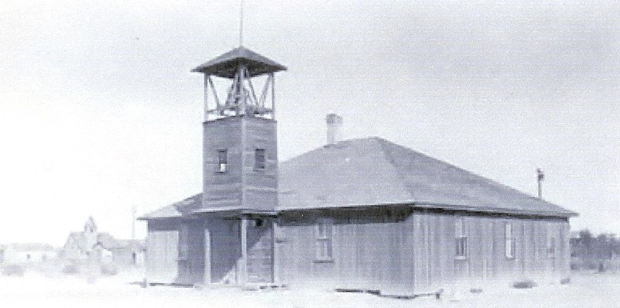
10/02/1905- Las Vegas School - 1st school building All grades
10/29/1910 Southwest corner of 2nd & Lewis
(Burned down on October 29, 1910)

10/1910- Methodist Church and Boarding House All grades
05/18/1911
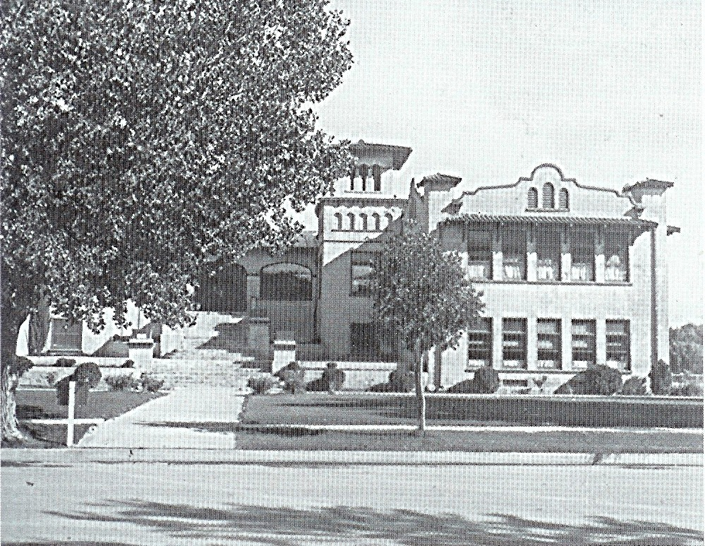
09/11/1911- Las Vegas School - 2nd school building All grades
12/1917 (Originally called Clark County School)
4th & Lewis
(Became part of 5th Street Grammar School
in 1936)

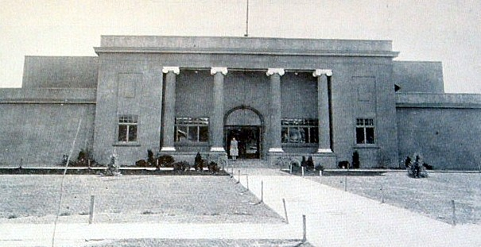
12/17/1917- Las Vegas High School - 1st high school High School
06/1930 building (Originally called Clark County
High School) - 4th & Clark
(Burned down May 24, 1934 (after new LVHS
opened) after it had been made part of
the grammar school)
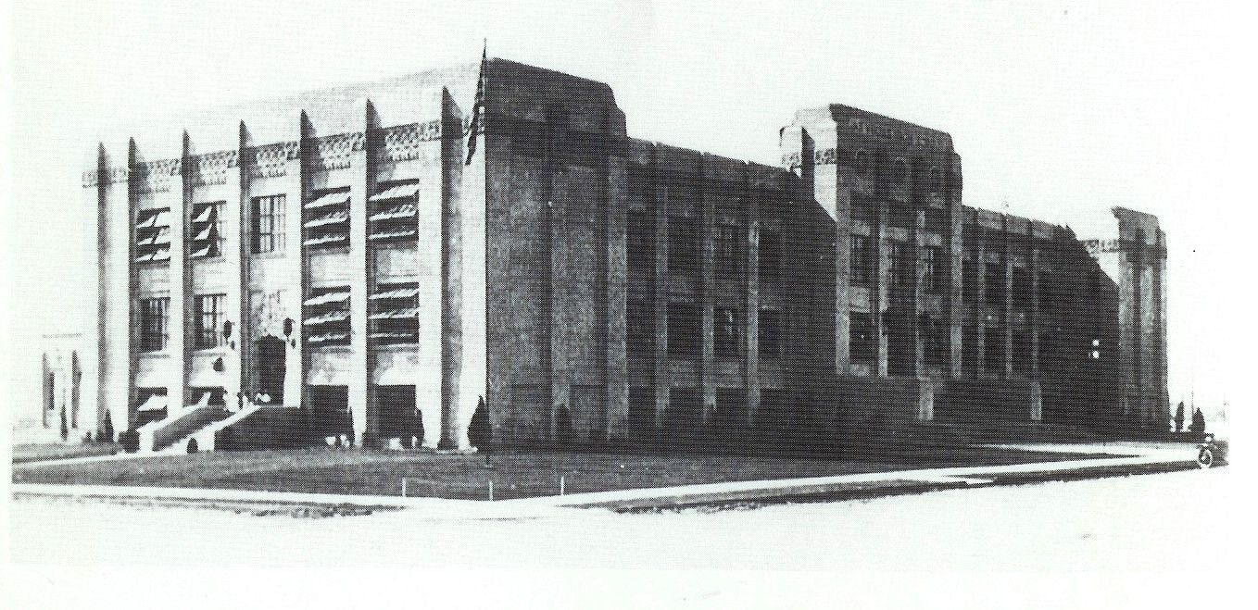
09/1930- Las Vegas High School - 2nd high school High School
06/1993 building - 7th & Bridger

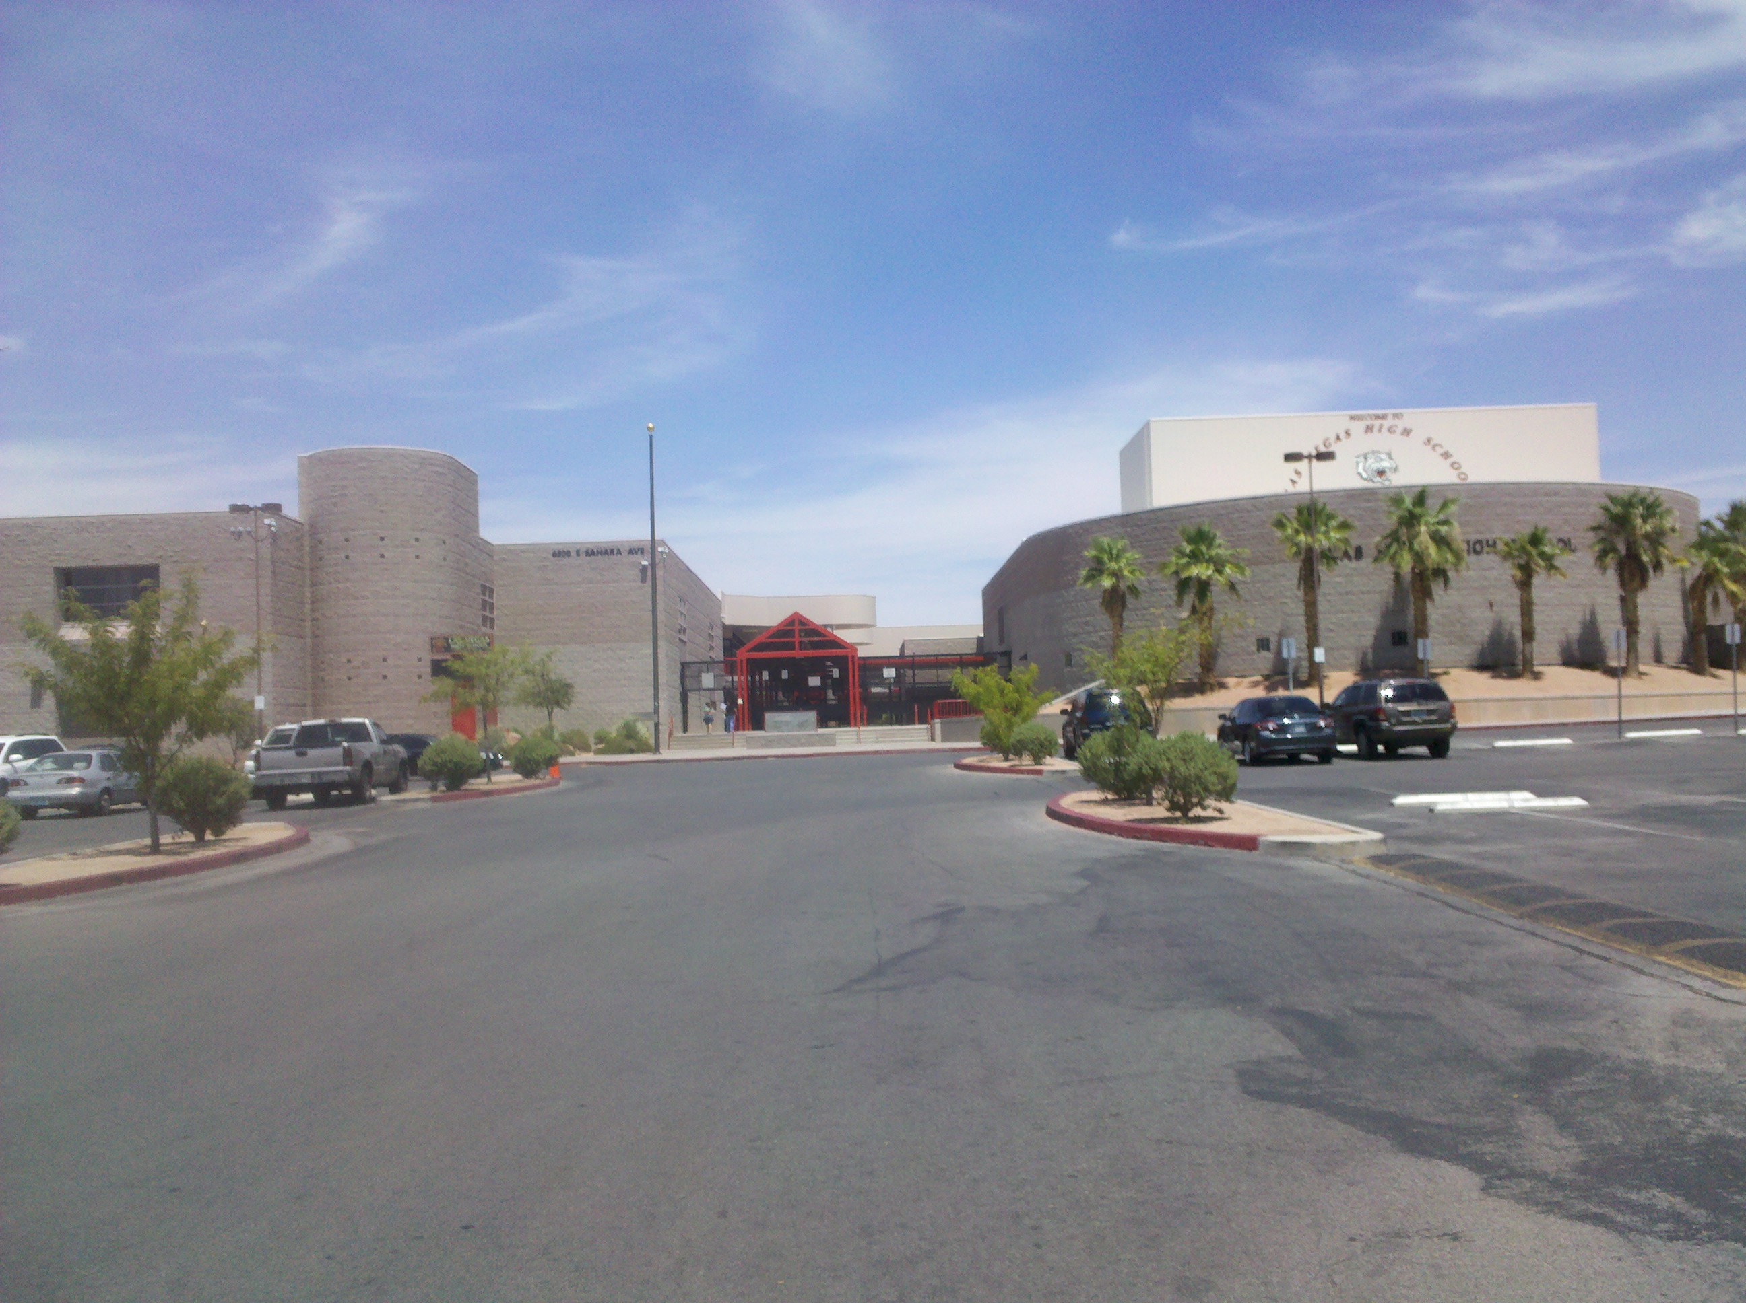
09/1993- Las Vegas High School High School
Present 6500 East Sahara

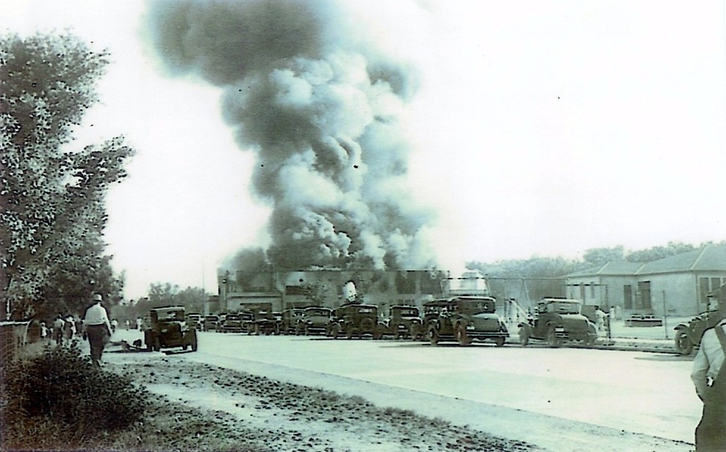

Original Las Vegas High School, near 4th & Clark, destroyed by fire
May 24, 1934 after it had become part of the grammar school.
Photo courtesy of Joylin Johnson Vandenberg, LVHS Class of 1945.

