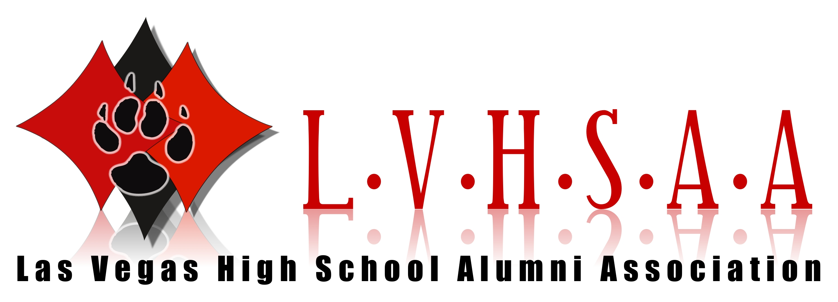

RICHARD W. BUNKER (Class OF 1952)

Richard W. Bunker was born in Las Vegas in 1933. After graduating from Las Vegas High, he served a three-year mission in Finland for the Church of Jesus Christ of Latter-day Saints. Upon his return, he enrolled at Brigham Young University, where he met his wife, Carole Ann Morgan. They were married in the St. George temple. Richard graduated from BYU in 1959 with a BS in Public Affairs and Economics. Richard was known for his service as Clark County Manager, Chairman of the State Gaming Control Board, an executive at the Circus-Circus, Dunes, and Aladdin hotels President of the Nevada Resort Association and Chairman of the Colorado River Commission. The University and Community College System of Nevada recognized him as a “Distinguished Nevadan” in 1993. He also received the Anti-Defamation League’s “Distinguished Community Service Award” in 1996. Richard passed away on March 17, 2019. He was married to Carole for 60 years and had 3 sons, 1 daughter, 12 grandchildren, and 2 great-granddaughters. He served in numerous callings in his church, including Bishop of the Las Vegas Fifteenth Ward, a member of the Lakes Stake High Council, a Gospel Doctrine Instructor in the Rainbow Ward and a worker in the Las Vegs temple.

These biographies are based on research and could contain discrepancies.
If there are, any excerpts you feel should be changed please feel free to contact dave@lvhsaa.com

WWW.LVHSAA.COM

